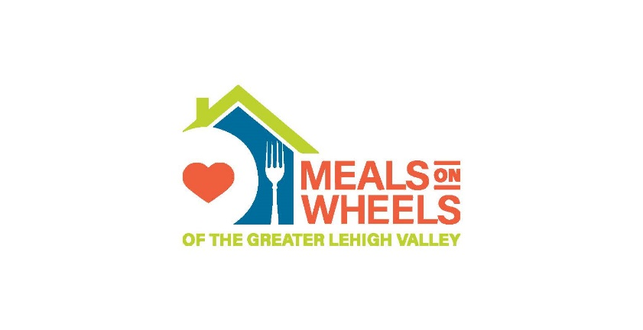
Meals on Wheels of the Greater Lehigh Valley is partnering with Brightstar Care of Stroudsburg & Allentown and Compassionate Care Hospice for a “Spring into Giving” food drive to benefit the Whitehall- Coplay Hunger Initiative Food Pantry. Any donations of the following would be greatly appreciated:

- Cereal – low sugar options (Cheerios, Honey Nut Cheerios or Rice Krispies)
- Quaker Instant Oatmeal Flavor Variety Pack: 10 packets per box
- Pasta/spaghetti sauce: 24 oz.jar
- Peanut butter: 16 oz. jar
- Canned vegetables: easy open, low sodium15.25 oz. can
- No salt added green beans in easy open can: 14.5 oz. can
- Tuna or Chicken: in water, pouches
- Reduced sodium chicken noodle or vegetable soup: 18.5 oz. easy open can
- Canned beans: 15.5 oz. easy open can
- Canned fruit or fruit cups: in water or light syrup, easy open cans

Thank you! Your support will make a real difference in the lives of many throughout the Lehigh Valley, and for that we are most grateful.

Questions? Please contact Dina Kovats-Bernat at dinak-b@mowglv.org or 610-419-6289.

